**NWIT 291 – Cybersecurity Capstone**

**Hands-on Lab**

**Lab 5- Burp Suite: Intercept Requests**

**Nimesh Giri**

**Montgomery College**

**NWIT-291-41341**

**Tesfaye Lemma**

**Lab 5- Burp Suite: Intercept Requests**

**1. Installation of burpsuite:**

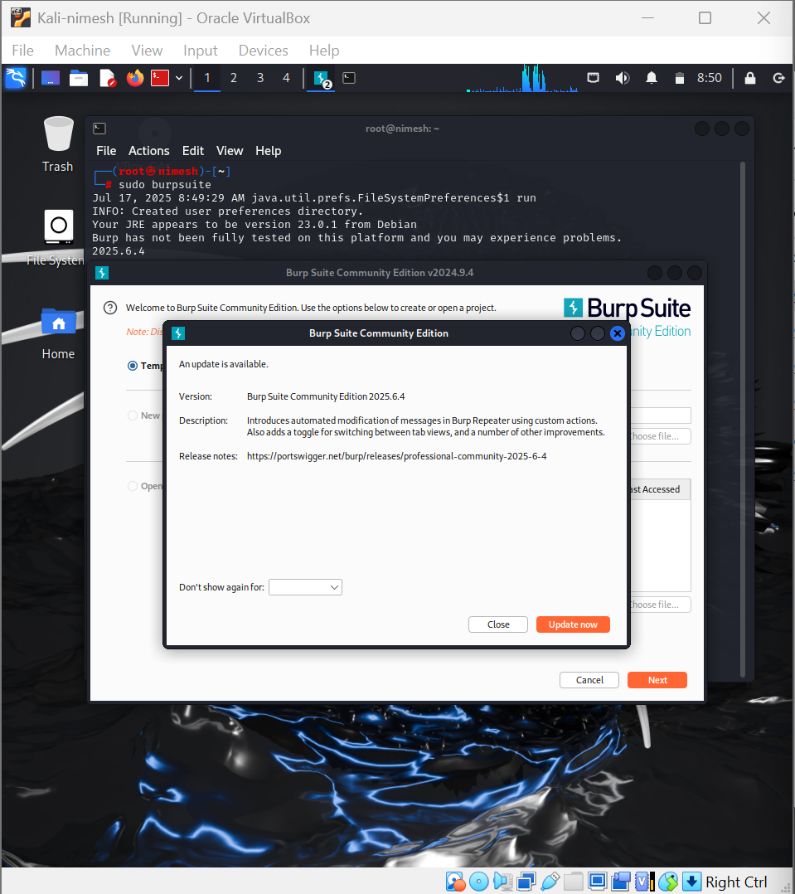

**2. Installation of FoxyProxy**

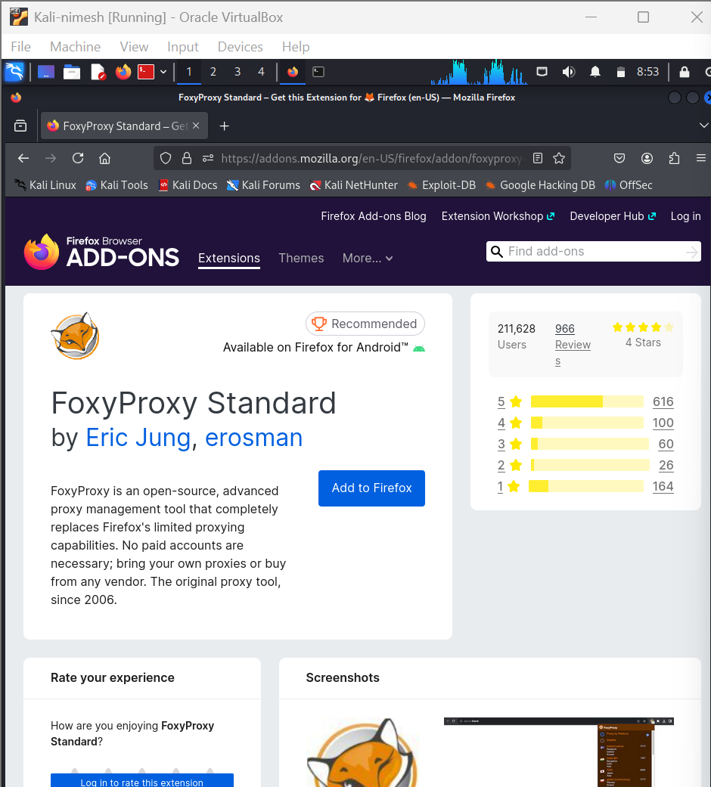

**3. Configuration of FoxyProxy**

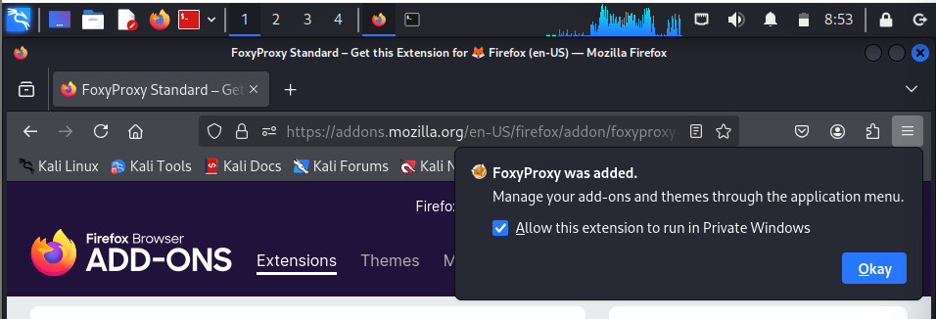

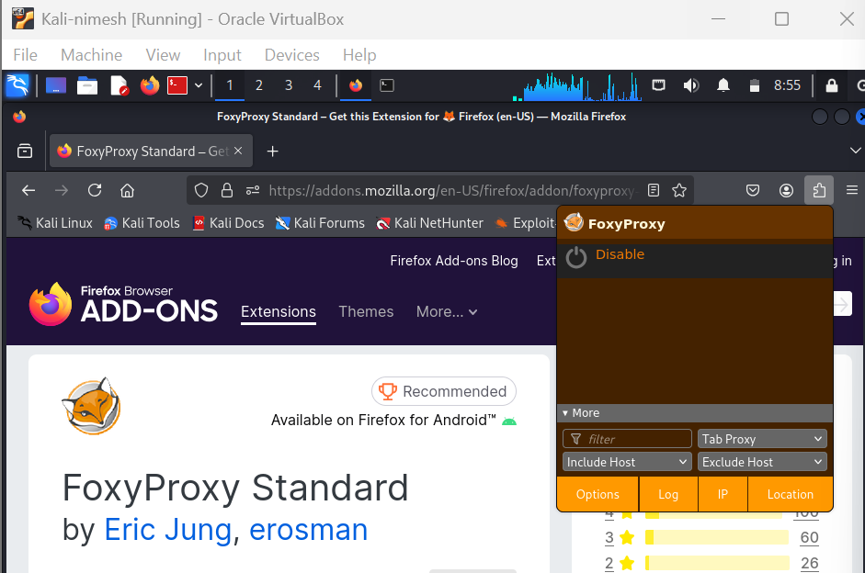

**4. Populating and saving the Proxies tab with host name and port number.**

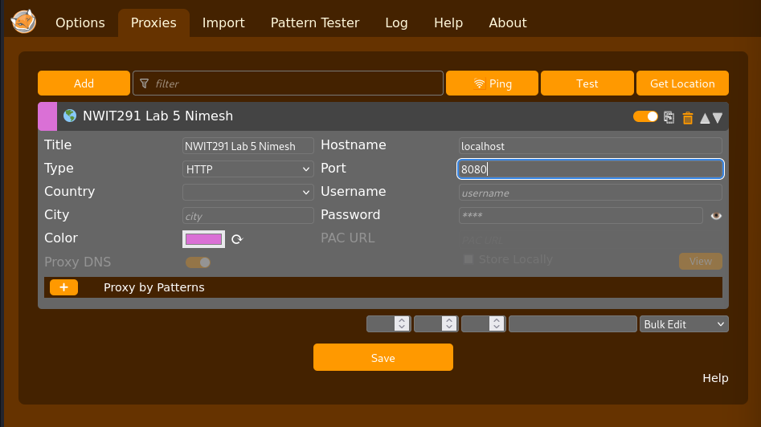

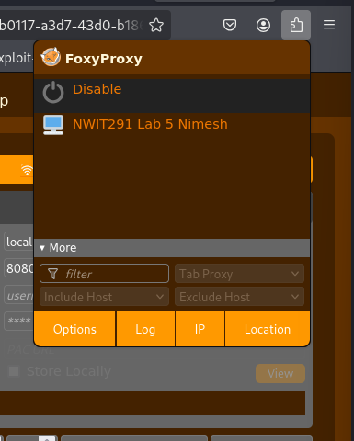

**5. Installing Burp's CA Certificate**

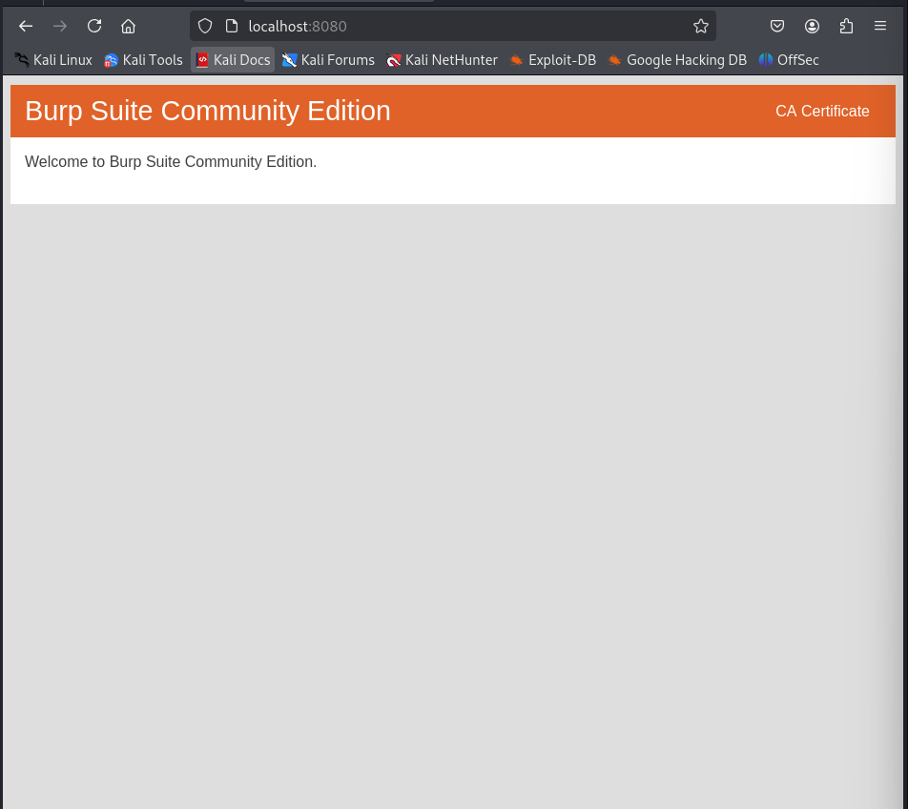

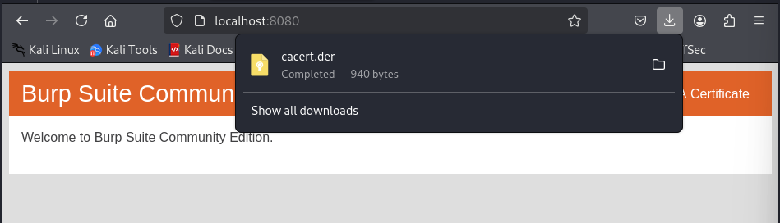

**Certificate Manager**

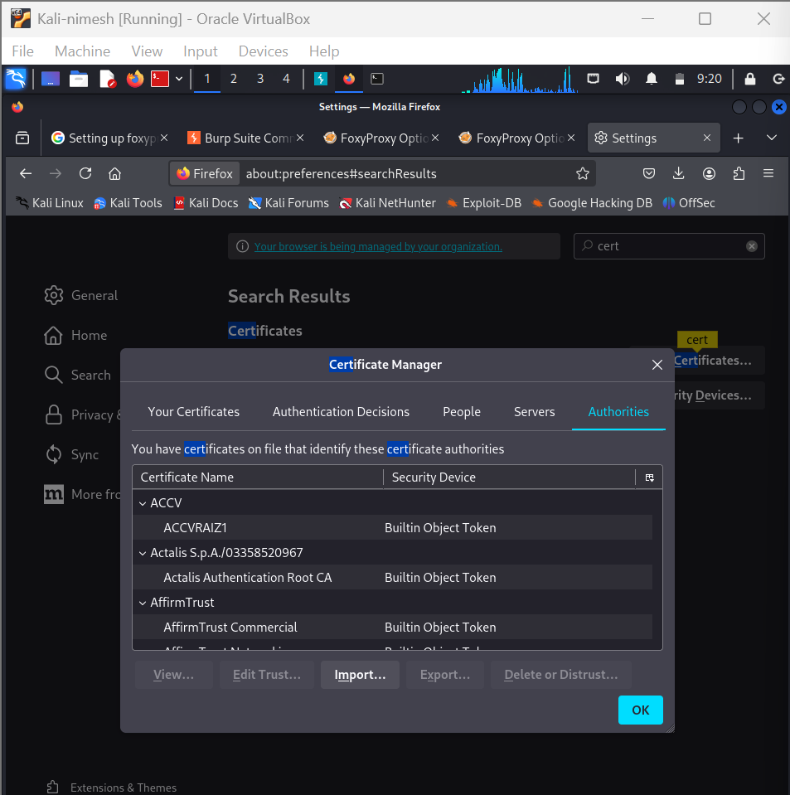

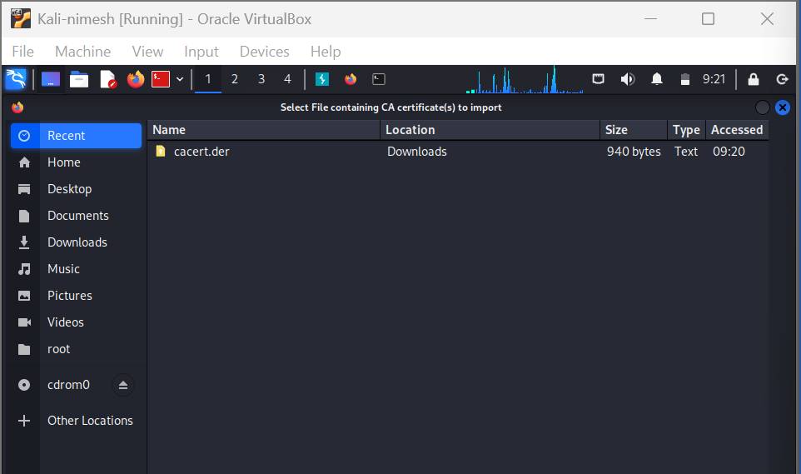

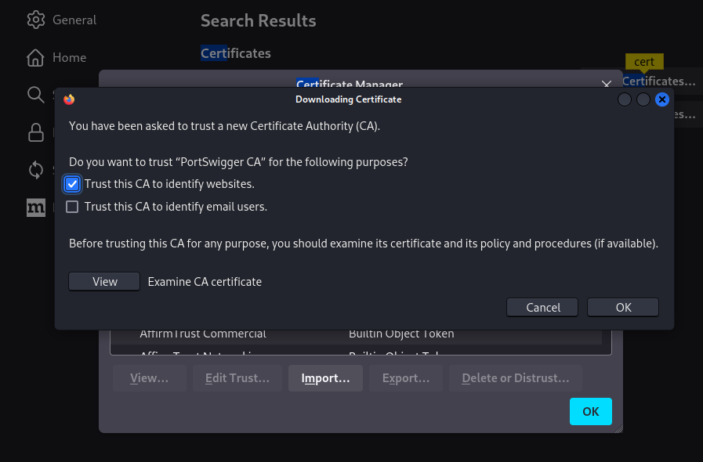

**6. Testing on Netflix**

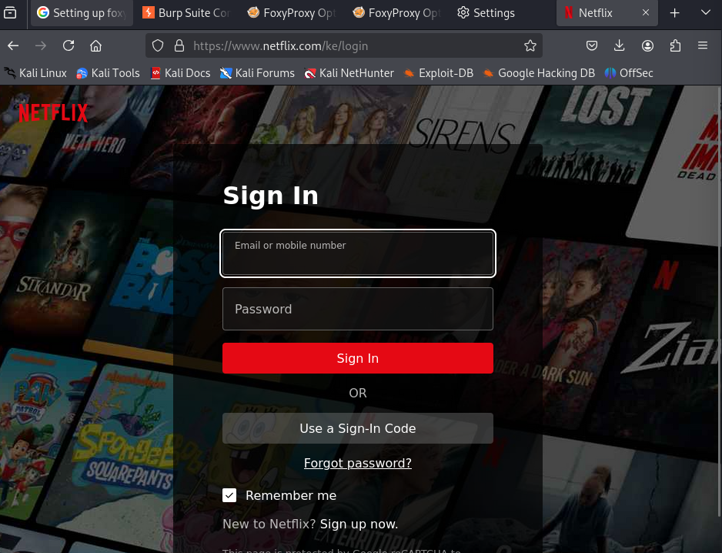

**7. Enabling intercept**

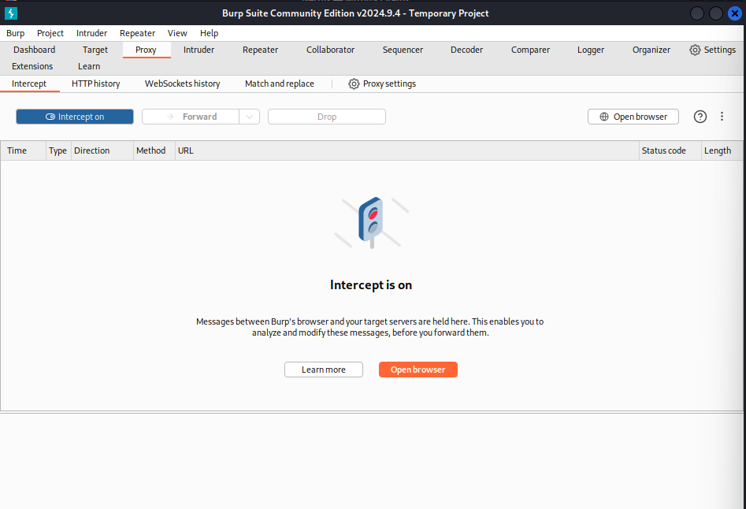

**8. Request interception**

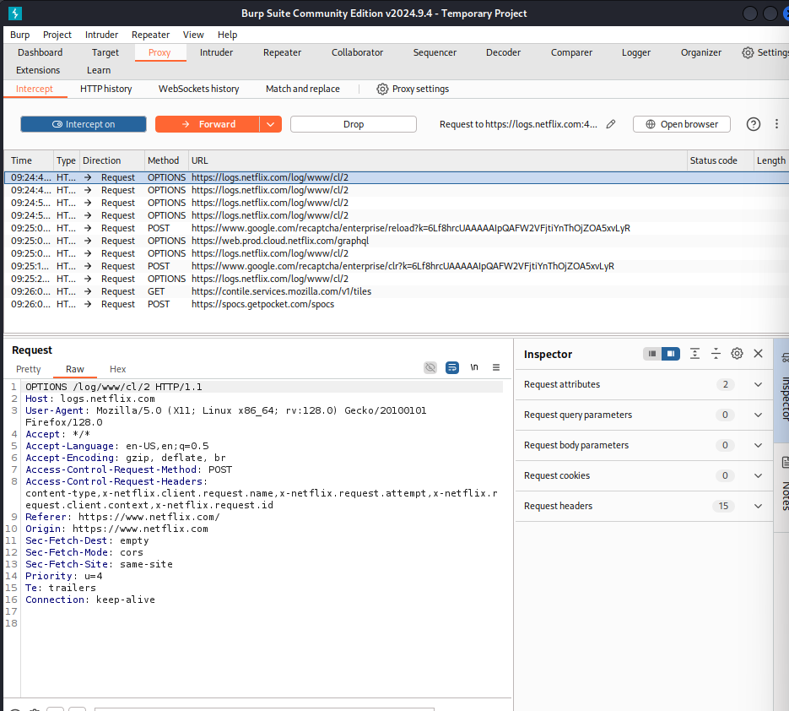

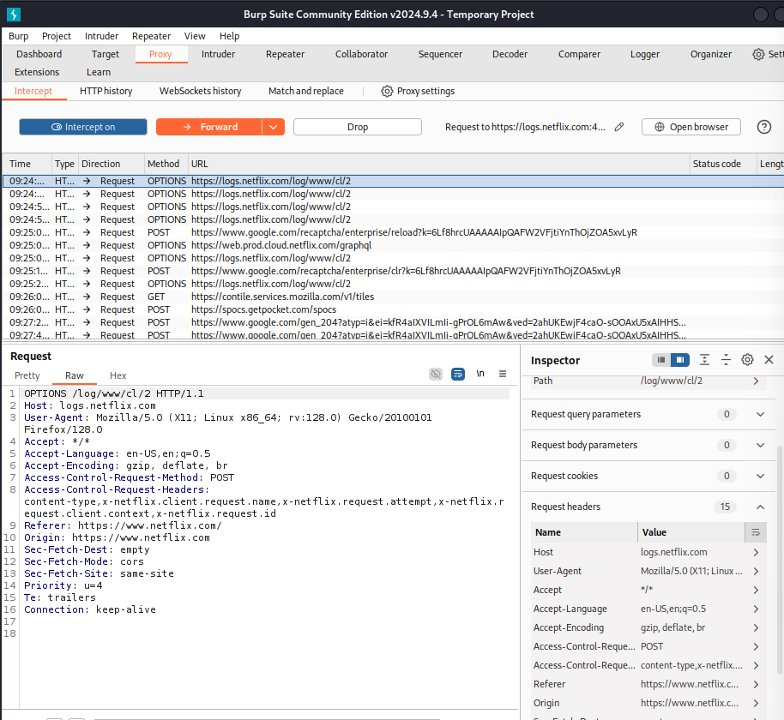

**9. Options under inspector**

